For access to your Dental insurance please do the following:
https://signin.guardianlife.com/signin
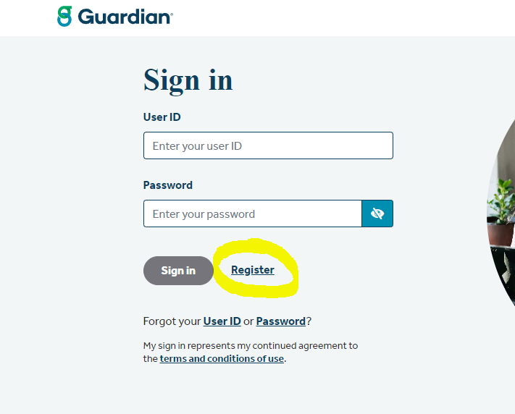
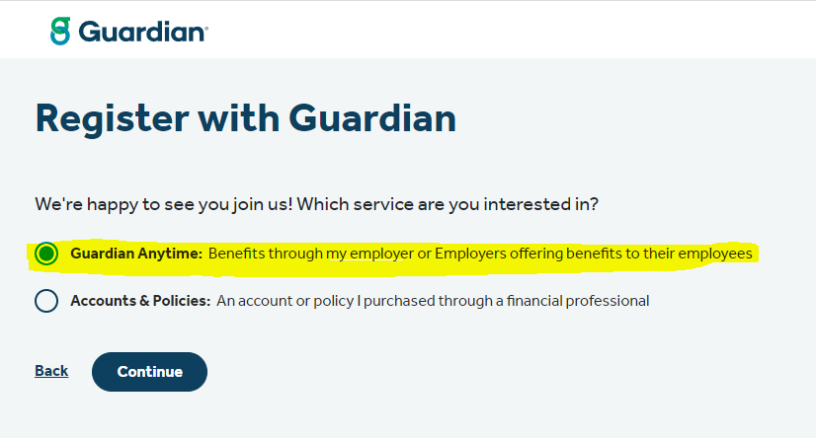
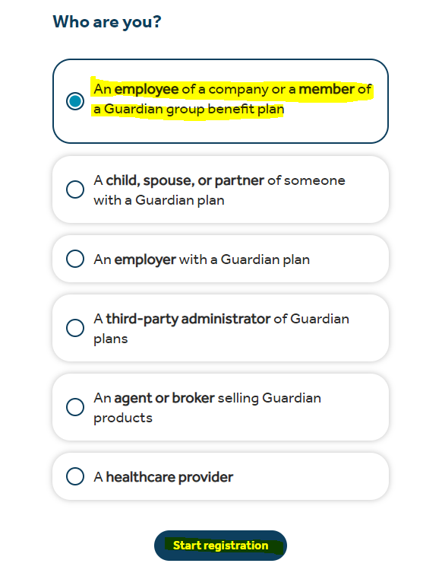
Then you will need to accept terms and enter your information. Last name, DOB, SS #. From here you will be able to access all of your information including cards.

